1. Design DFA using simulator to accept the input string “a” ,”ac”,and ”bac”.

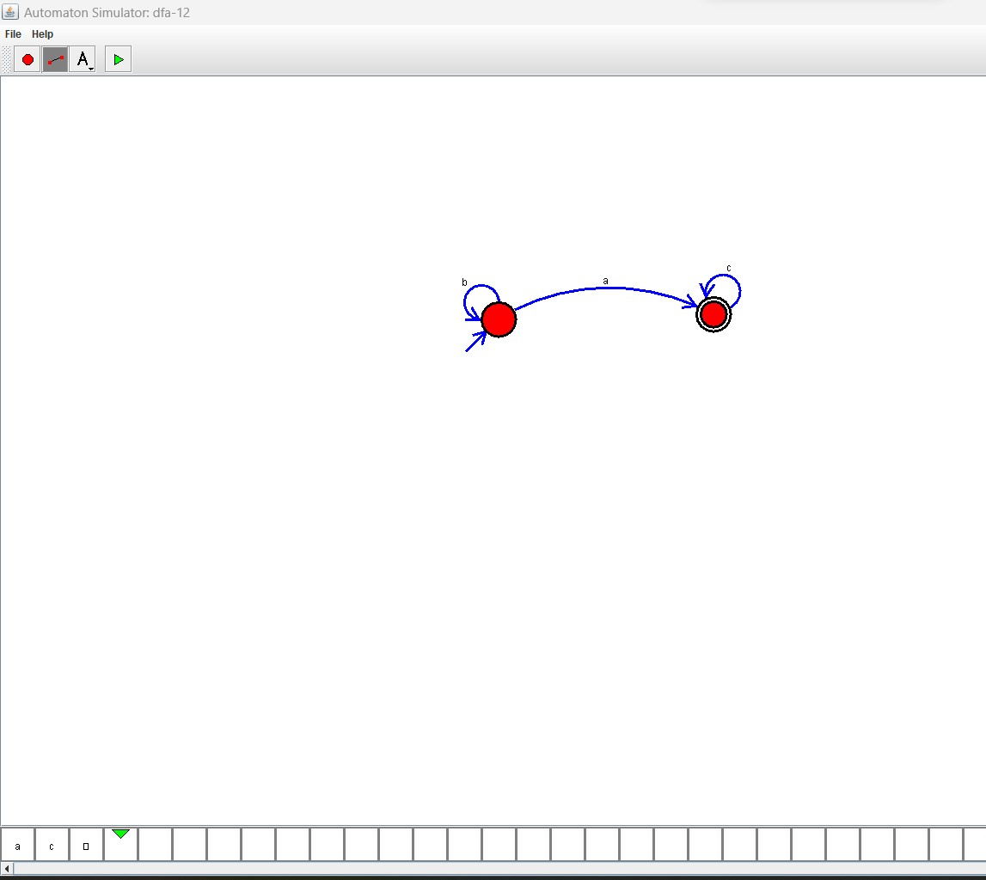

**RESULT**: THE DFA RUN SUCCESFULLY USING SIMULATOR BASED ON GIVEN STRINGS.